### Kindergarten Supplies

2015-16 School year

All supplies in kindergarten become part of a community pool. Please mark your child’s name on the backpack, lunch box, and P.E. shoes only.

4 boxes of basic color crayons

(16 or 24 count Brand Crayola or

Roseart)

2 boxes of washable markers

(8+ count)

1 dozen #2 wooden pencils

4 – 4oz bottles of Elmer’s glue

10 glue sticks

1 large box of Kleenex

3 packs of stickers

1 box Ziploc gallon size bags

1 box Ziploc sandwich size bags

1 washable water color paint set

8 colors 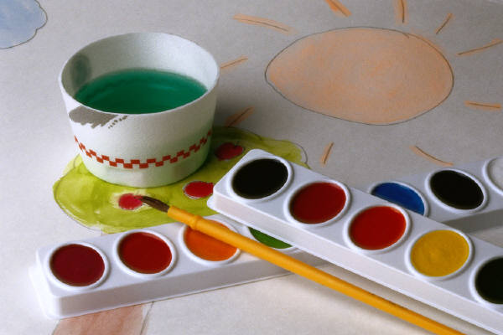

1 box colored pencils

1 empty frosting container

1 backpack for carrying items to

and from school, large enough

to hold a 9x11 folder, shoes,

and possibly a lunchbox. Please check for a good quality zipper and have your child try zipping it in the store.

Tennis shoes must be worn to school on the scheduled P.E. day. (Some parents prefer to have a pair that is kept at school. This is very helpful during the winter months.)

Please, if your child can’t tie shoes then choose shoes that do not require adult help. (Velcro, stretchy laces)